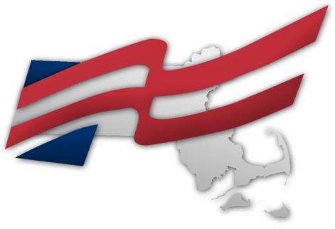

Newton South

FUTURE BUSINESS LEADERS OF AMERICA

COMPETE

Participate in a wide variety of competitions against 250,000 of America’s top high school students.

WIN

We’ve produced 23 top three finishes and four national finalists in the last two years.

TRAVEL

Visit iconic U.S. cities at one of FBLA's conferences. Upcoming destinations include Atlanta, Baltimore and Disneyland.

|  |
| --- |
| JOIN US & LEARN MORE September 15  J Block • Room 1302 |